Sprint - 2

|  |  |
| --- | --- |
| Date | 18 November 2022 |
| Team ID | PNT2022TMID20469 |
| Project Title | Industry - specific intelligent fire management system |

MONITORING SENSOR VALUES

Display the temperature values,flame sensor,gas sensor in the dashboard: Submitted by

Manoj K – 49621911082

Pradeepa S – 49621911096

Mugesh S -49621911033

Jayasri M – 49621911068

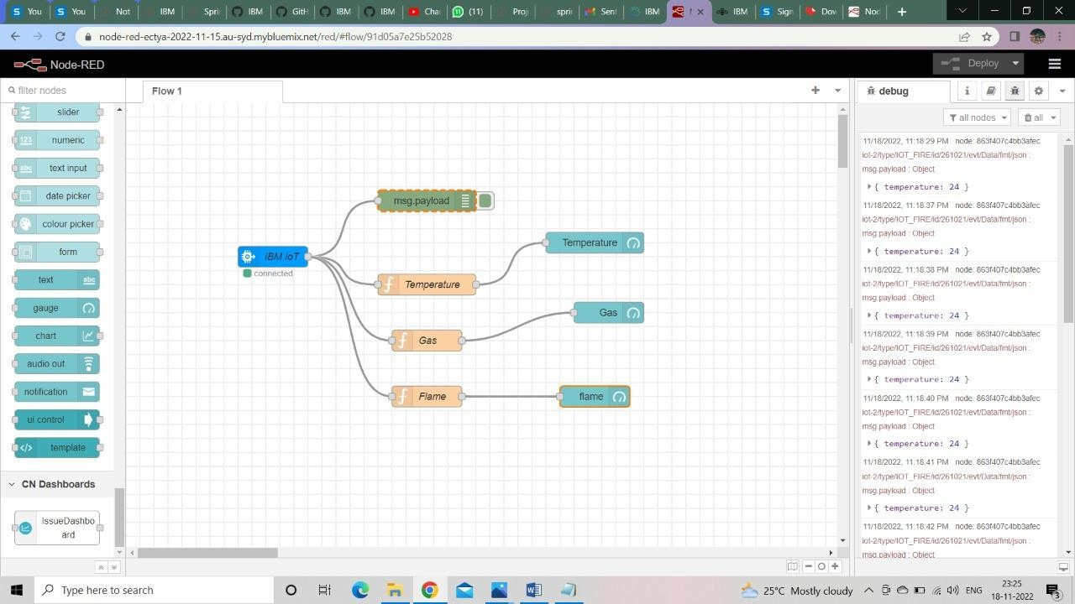

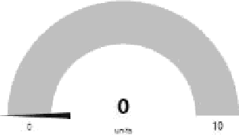

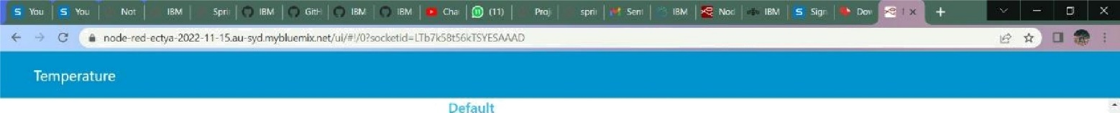

flame

Temperature

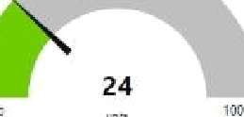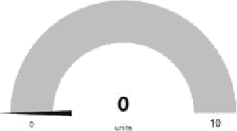 g